Ako Kupu
Te Reo Māori Learning Platform

Live app: Ako Kupu · Te Reo Māori Flashcards
Confluence: Ako Kupu
Jira Board: Ako Kupu | Backlog
GitHub Repository: eirikrbe/Ako-Kupu
Eric Gomez Group E
270856490
19/07/2026
MSE800

Executive Summary

Ako Kupu is a web-based platform that allows ākonga (students) to practise Te Reo Māori vocabulary through short flashcard sessions of five cards, while kaiako (teachers) manage the learning content through the same interface without requiring technical knowledge. The name combines kupu (words) and ako (reciprocal learning between kaiako and ākonga), which reflects the central idea of the product: both roles participate in shaping the learning. The system not only tracks each student's progress per category over time but also incorporates an AI learning layer built on the Google Gemini API, which generates personalised feedback after each session and provides Hoa Ako, a conversational tutor available while practising.
The project was developed by a two-person team (Group E) following an Agile Scrum methodology, organised as Day 0 plus three sprints over five weeks and tracked end-to-end in Jira (3 epics and 38 tasks — 37 delivered, one descoped); GitHub branches, commits, and pull requests were linked automatically to their corresponding issues, and Confluence was used for meeting minutes and sprint documentation. The technology stack consists of Flask with server-rendered Jinja2 templates, PostgreSQL accessed through raw psycopg 3, Docker for containerisation, and Render for hosting.
The final product is deployed and publicly accessible on Render, backed by a Neon PostgreSQL database. The codebase closed with 193 automated offline tests and a pylint score of 9.85/10; furthermore, a documented acceptance run against the production deployment confirmed that all 9 success criteria and all 3 AI criteria pass. The three supervisor approval conditions were also met: the application is live on free hosting, it is Dockerised, and it integrates an AI/LLM API.
Table of Contents
1. Introduction 4
1.1 Project Background 4
1.2 Project Objectives 4
1.3 Development Methodology 4
1.4 Technology Stack 5
2. Team Formation 5
2.1 Team Structure 5
2.2 Team Collaboration 5
2.3 Communication Strategy 6
2.4 Cultural Diversity 6
2.5 Partnership Principle 7
3. Project Kickoff & Requirement Gathering 7
3.1 Kickoff Meeting 7
3.2 Stakeholders 8
3.3 Problem Statement 8
3.4 Requirement Gathering 8
3.5 User Roles 9
4. Requirement Analysis & Prioritisation 9
4.1 Prioritisation Strategy 9
4.2 Community Needs 10
4.3 User Stories 10
4.4 Functional Requirements 11
4.5 Non-functional Requirements 12
5. Agile Development 12
5.1 Agile Methodology 12
5.2 Development Tools 12
5.3 Sprint Overview 13
5.3.1 Day 0 14
5.3.2 Sprint 1 14
5.3.3 Sprint 2 14
5.3.4 Sprint 3 14
5.4 Sprint Deliverables 15
5.5 Product Backlog 16
5.6 Development Metrics 16
5.7 Collaboration & Version Control 17
6. Software Design & Architecture 18
6.1 System Architecture 18
6.2 Database Design 19
6.3 Object-Oriented Design 20
6.4 AI Architecture 20
6.5 Deployment Architecture 21
6.6 Key Design Decisions 21
7. Cost Estimation 21
7.1 Labour Costs 21
7.2 Tools & Services 22
7.3 Resources 23
7.4 Project Cost Summary 23
8. Acceptance Criteria & Testing 23
8.1 Testing Strategy 23
8.2 Acceptance Criteria 23
8.3 Test Results 24
8.4 Production Validation 25
8.5 Cultural Acceptance 25
9. Challenges & Lessons Learned 26
10. Te Tiriti o Waitangi & Cultural Considerations 27
10.1 Partnership 27
10.2 Participation 27
10.3 Protection 27
10.4 External Cultural Engagement 28
11. Ethical Use of Data & Tools 29
11.1 Dataset 29
11.2 Tools 29
11.3 Personal and sensitive data 29
11.4 Access to project materials. 29
12. Conclusion 30
13. References 30
14. Appendices 31
15. Figures 31
16. Tables 32

Introduction

Project Background

Ako Kupu was developed with the aim of satisfying the Te Reo Māori educational problem; what it addresses is the absence of a simple, structured, and culturally grounded digital tool for ākonga (students) to practise Te Reo Māori vocabulary at their own pace, or for kaiako (teachers) to manage and organise learning content without technical knowledge. It is also necessary to note that both developers were themselves learners of te reo working inside their own product; this circumstance shaped a consultative and culturally careful way of working from the beginning of the project.

Project Objectives

The project aimed to deliver a working web application in which ākonga can practise vocabulary through five-card flashcard sessions, receive a score with the missed kupu (words) listed, and follow their progress per category over time, while kaiako create, edit, and organise the flashcard content and an administrator manages user accounts and roles. In addition, three approval conditions defined by the supervisor were treated as non-negotiable scope: the application had to be live on free hosting, it had to be Dockerised, and it had to integrate an AI/LLM API. Beyond the functional scope, the team set explicit quality objectives, such as an automated test suite, a pylint score of at least 8.0 across the application code, and culturally careful handling of all Te Reo Māori content, including formally requested permission for reused material.

Development Methodology

The team followed an Agile Scrum approach organised as Day 0 plus three sprints over five weeks. Each sprint was represented in Jira as an epic, and every issue carried sprint and area labels; one issue corresponded to one branch and one pull request into main, and the GitHub-for-Jira integration linked branches, commits, and pull requests to their issues automatically. The Definition of Done required that the feature worked locally, that pylint remained at or above 8.0, that the tests passed, and that the Jira issue and the Confluence sprint page were updated. The sprints and their outcomes are described in detail in the Agile Development section of this report.

Technology Stack

The application is built with Flask and server-rendered Jinja2 templates; the data layer is PostgreSQL, hosted on Neon and accessed through raw psycopg 3, so that all SQL remains in a single DatabaseManager class. Docker provides a consistent environment between development and production, and Render deploys the container automatically on every push to main. The AI features are implemented on the Google Gemini API (gemini-2.5-flash). In order to support collaboration, the team used GitHub for version control and pull requests, Jira for the backlog and sprint tracking, and Confluence for documentation and meeting minutes.

Team Formation

Team Structure

Group E is a two-person development team. The ownership model was deliberately simple: each member owns one complete layer of the application, and every Jira issue carries an area label (area-backend, area-frontend, area-shared) that makes this ownership visible on the board. The following table summarises the roles and responsibilities of each member.

Table 1
Team Structure
Member | Role | Responsibilities | Jira tasks
Eric Gomez | Backend developer | Routes, models, DatabaseManager (all SQL), AI service layer, database schema, automated tests | 25
Yirong Chen | Frontend developer | Jinja2 templates, CSS design system, JavaScript, UI design, deployment verification | 12

Team Collaboration
Work was divided by layer rather than by feature, so that both members could build in parallel without blocking each other: Eric owned the backend (routes, models, and all SQL through the DatabaseManager class) while Yirong owned the frontend (Jinja2 templates, the CSS design system, and JavaScript). The seam between the two layers is a frozen interface contract (docs/template-context-contract.md) that fixes, for every route, which template renders and the exact context dictionary it receives. The frontend was therefore built against mock context while the backend implemented the real routes; whenever a shape changed, the contract changed in the same pull request.
Figure 1
GitHub Tree Sprints 1 and 2
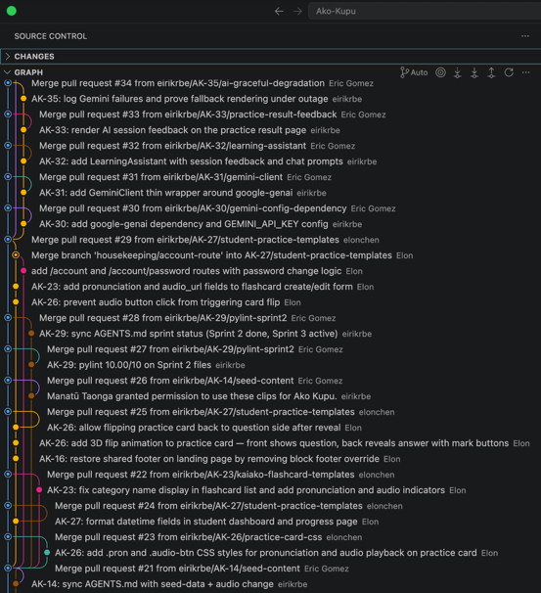

Communication Strategy

The team communicated through the toolchain rather than through long meetings. Jira was the single source of truth for task allocation and sprint status; Confluence recorded documentation and embedded live Jira tables, so the published plan always reflected real statuses; GitHub pull requests served as the code review channel, with one branch and one pull request per issue. In addition, short minuted sessions were held for decisions that could not be resolved asynchronously, such as requirement refinement and sprint planning.

Cultural Diversity

Group E is a two-culture team whose working language is English and whose product language is Te Reo Māori; consequently, both developers were learners inside their own product. Since neither member is a native speaker of te reo, the team adopted a consultative approach in which decisions about kupu, macrons, and pronunciation were verified rather than assumed. This shared position also influenced the collaboration style: explicit written agreements, such as the interface contract and the labelled backlog, were preferred over implicit conventions that could be misread across cultures.

Partnership Principle

Consistent with the partnership principle of Te Tiriti o Waitangi, the team did not treat te reo as freely available data. Before reusing the pronunciation audio of the "100 Māori words" resource, permission was formally requested from Manatū Taonga Ministry for Culture & Heritage; the request was approved by Jamie Mackay, Pou Taki ā Matihiko Matua | Senior Adviser Digital (Figure 2), and the correspondence is archived in the repository. This exchange represents the partnership principle in practice: the team engaged directly with the organisation responsible for the material and waited for its approval instead of assuming consent.

Figure 2
Permission request — reuse of "100 Māori words" pronunciation audio
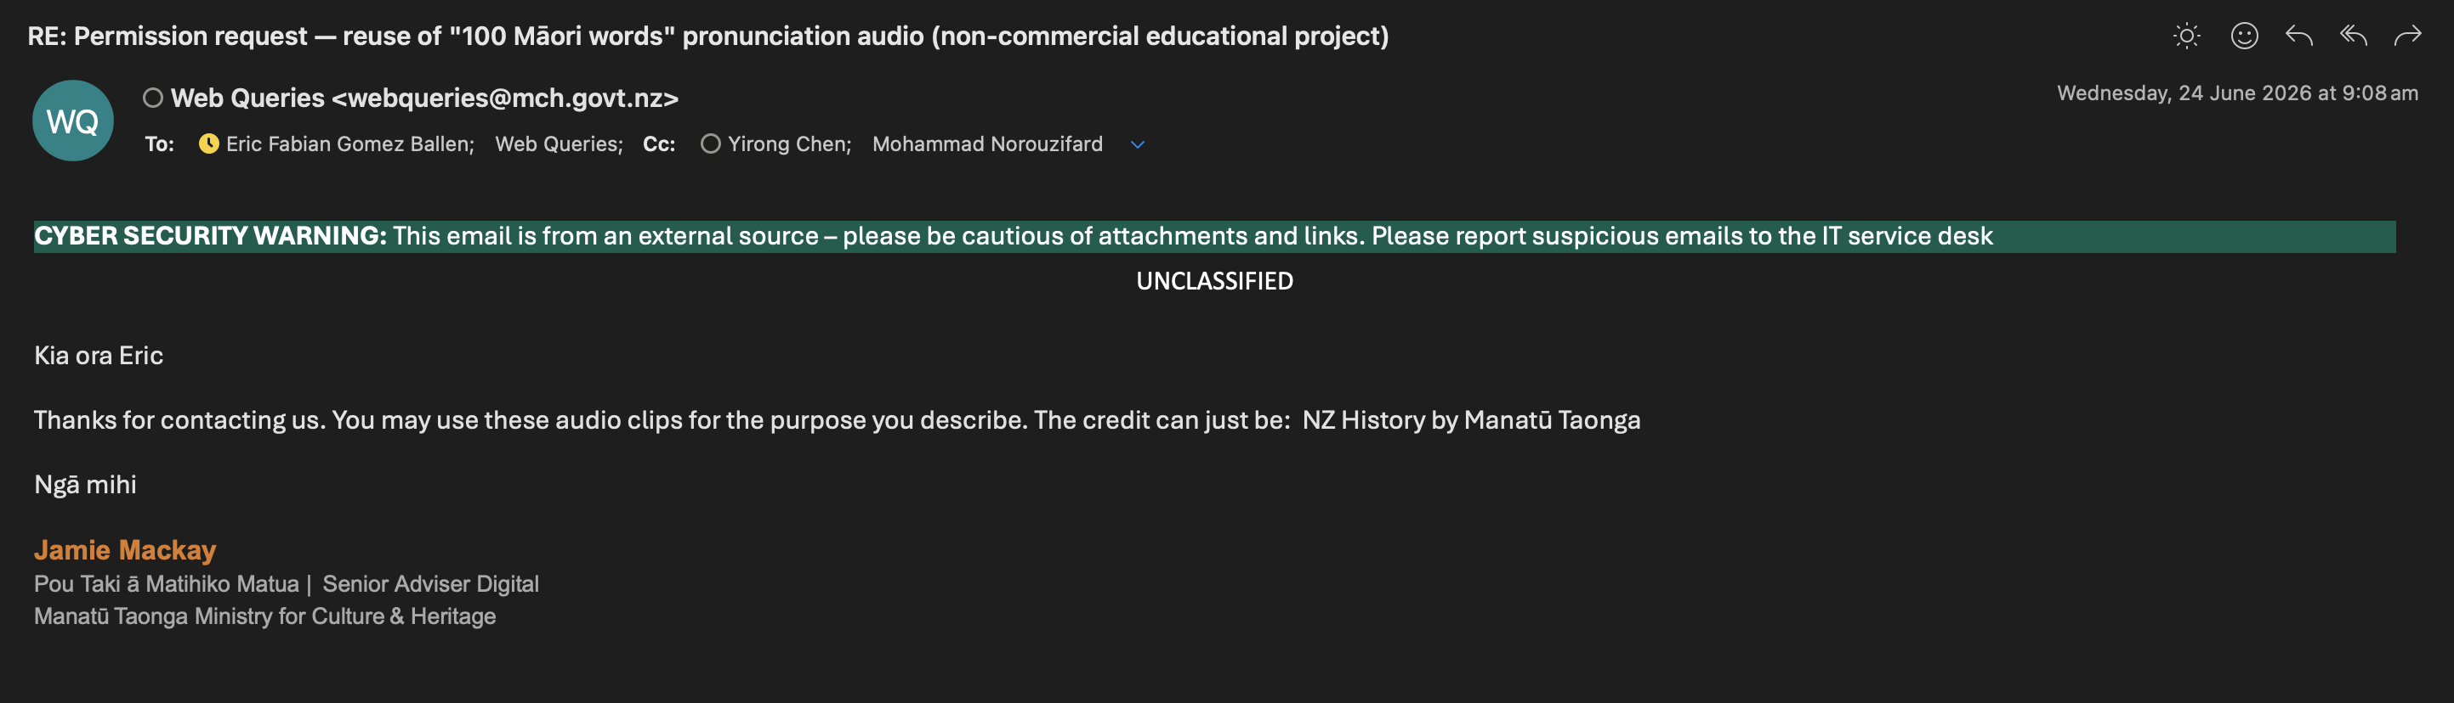

Project Kickoff & Requirement Gathering

Kickoff Meeting

The kickoff meeting took place on Day 0 (01 June 2026) with both team members present. Following the assessment scenario, the team acted as both the client and the development company; in practice, each member played the client for the other member's layer, which meant that requirements were presented, questioned, and defended inside the same session. The meeting fixed the problem statement, the three user roles, the technology stack, and the supervisor's three approval conditions (free hosting, Docker, and an integrated AI/LLM API) as non-negotiable scope. The Māori dimension of the project was also agreed explicitly at this stage: te reo content would be treated as taonga, and permission would be formally requested for any reused language material, consistent with the three principles of Te Tiriti o Waitangi.

Stakeholders

Four stakeholder groups were identified at kickoff. Ākonga (students) are the primary users, who need short, structured practice and visible progress; kaiako (teachers) own the learning content and need to manage it without technical knowledge; the administrator maintains user accounts and role assignments; and Manatū Taonga Ministry for Culture & Heritage is an external stakeholder, since the pronunciation audio in the seed content is reused with its formal permission (Figure 2).

Problem Statement

The problem the software solves was defined at kickoff and remained stable throughout the project: there is no simple, structured, and culturally grounded digital tool for ākonga to practise Te Reo Māori vocabulary at their own pace, or for kaiako to manage and organise learning content without technical knowledge. The statement deliberately names both sides of the learning loop; therefore, features for ākonga and features for kaiako were treated as equally essential rather than as product and administration.

Requirement Gathering

Requirement gathering continued after kickoff through short, minuted sessions rather than a single long workshop; the Jira backlog was the single output of the process, so every agreed requirement became either a specification row or a backlog task, and nothing remained only in notes. Feedback operated in both directions: since each member acted as the client for the other's layer, requirements were refined by the person who would consume them, which kept them concrete and testable. Cultural requirements were gathered with the same discipline; questions about macrons, pronunciation, and the grouping of the seed vocabulary were checked against the source material rather than resolved by assumption, and the resulting decisions entered the backlog as ordinary, reviewable items.

User Roles

The system defines three roles with clearly separated permissions, summarised in the following table. Role separation is enforced in the code by a role_required decorator on every protected route; consequently, a user with the wrong role receives a 403 response rather than a hidden menu option.

Table 2
User Roles and Permissions
Role | How created | Responsibilities
Ākonga (student) | Self-registration (open) | Practise flashcards, view own progress
Kaiako (teacher) | System-provisioned | Manage flashcards and categories, including archive and unarchive
Admin | System-provisioned | Manage users: view list by role, add kaiako accounts, change roles

Requirement Analysis & Prioritisation

Prioritisation Strategy

Requirements were prioritised by business value to the learning loop and then mapped directly onto sprints, so that each sprint shipped a usable increment rather than a horizontal slice of infrastructure. Sprint 1 delivered trust first, since nothing matters without secure accounts and role separation (authentication with bcrypt, role-based access control, and the role dashboards); Sprint 2 delivered the core loop, that is, kaiako content management and the ākonga practice flow with progress tracking, which are the product's reason to exist; Sprint 3 delivered differentiation and hardening: the AI layer (a supervisor condition and the main learner-value add), acceptance testing, documentation, and the verified production deployment.

Community Needs
Local community needs were treated as first-class requirements rather than decoration. Macrons, pronunciation guides, and audio are schema columns (pronunciation, audio_url), which means that correct te reo presentation is enforced by the data model instead of depending on whoever enters the content; the seed vocabulary keeps the topic grouping of its source material; and permission for the "100 Māori words" pronunciation audio was formally requested from Manatū Taonga Ministry for Culture & Heritage and approved (Figure 2). Consequently, the Māori perspective influenced not only what was built but also how the content was sourced, since reusing existing language material required an explicit request and a documented approval rather than a silent download.

User Stories
The complete set of 14 user stories, organised by role and carrying acceptance criteria and a link to their functional specification, is reproduced in the Appendix. The following table presents the most representative stories: the ones that define the learning loop, the AI layer, and the content management surface.

Table 3
Representative User Stories and Acceptance Criteria
ID | User story | Acceptance criteria | Spec
US-01 | As an ākonga, I want to register with my email and a password so that I can start practising. | Account created; password stored only as a bcrypt hash; redirected to login. | FR-01, FR-05
US-04 | As an ākonga, I want to flip through 5 cards per session so that practice stays short and focused. | Card front shows the kupu; flip reveals the meaning without a page reload. | FR-15–FR-17
US-06 | As an ākonga, I want a session summary with my score and missed kupu so that I know what to revise. | Score, percentage, and the missed cards listed. | FR-19
US-07 | As an ākonga, I want personalised feedback after a session so that revision advice fits my mistakes. | AI paragraph names the missed kupu; page renders fine without AI. | FR-21, FR-23
US-08 | As an ākonga, I want to see my progress per category so that I can watch myself improve. | Cumulative attempts, correct count, and accuracy per category plus overall. | FR-20
US-09 | As an ākonga, I want to ask a tutor questions in/about Te Reo while practising so that I'm never stuck. | Hoa Ako widget replies conversationally; graceful fallback when AI is off. | FR-22, FR-23
US-11 | As a kaiako, I want to create, edit, and delete flashcards of three types (vocabulary, phrase, whakataukī) so that content fits how te reo is actually taught. | Type-specific validation; list filterable by category and paginated. | FR-08–FR-11
US-12 | As a kaiako, I want to organise cards into categories and archive stale ones so that ākonga always see a tidy set. | Create, edit, archive, unarchive; archived categories hidden from practice. | FR-12, FR-13, FR-27, FR-28
US-14 | As an admin, I want to view all users by role, add kaiako accounts, and change roles so that access stays correctly assigned. | Role tabs; inline add-kaiako form (bcrypt); role change takes effect immediately. | FR-24–FR-26

Functional Requirements

The system implements 31 functional requirements (FR-01 to FR-31) covering authentication, flashcard management, the practice flow, the AI layer, administration, and the public pages; the complete table, in which every row carries a description, a sprint, and an implementation pointer into the codebase, is reproduced in the Appendix. All 31 requirements were implemented and verified. Representative examples illustrate the level of detail: FR-04 requires that a user with the wrong role receives a 403 response, which is enforced by the role_required decorator on every protected route; FR-19 requires that a practice result shows the score, the percentage, and the missed kupu, verified live with a 3/5 session; FR-23 requires that a missing API key or an AI failure never causes a 500 error, verified both locally and by offline outage tests.

Non-functional Requirements

In addition to the functional surface, 23 non-functional requirements (NFR-01 to NFR-23) constrain security, object-oriented design, code quality, infrastructure, and usability; the complete table is reproduced in the Appendix. Three examples show their character: NFR-06 requires that User and Flashcard are abstract base classes (abc.ABC) that are never instantiated directly, which is enforced in the models and unit-tested; NFR-12 requires a pylint score of at least 8.0 across the application code, and the project closed at 9.85/10; NFR-14 forbids an ORM, so that all SQL lives in the DatabaseManager class, a decision that later made the database migration trivial.

Agile Development

Agile Methodology

The team applied Scrum adapted to a two-person company. The product backlog was created in Jira at the start of the project window; each sprint is a Jira epic, every issue carries sprint and area labels, and one issue corresponds to one branch and one pull request into main. Sprint planning selected the issues that would make the increment usable on its own, following the priorities described in Section 4; at the end of each sprint the increment was reviewed against the Definition of Done, and the observations fed the planning of the next sprint. The clearest example of this rhythm is the deliberate pause between Sprint 2 and Sprint 3 (29 June to 5 July), which was used for the examination period and for planning the AI layer. The Definition of Done was explicit and constant throughout the project: the feature works locally, pylint remains at or above 8.0, the tests pass, the Jira issue is moved to Done, and the Confluence sprint page reflects the change.

Development Tools

Each tool had one clear responsibility, summarised in the following table.
Table 4
Development Tools and Responsibilities
Tool | Responsibility in the project
Jira | Backlog and sprint boards; the Development panel shows, for every issue, the branch, commits, and pull request that implemented it
Confluence | Documentation and meeting minutes; embeds live Jira tables, so the published plan cannot drift from the board
GitHub | Version control and the pull-request review channel; a scheduled GitHub Action sends a daily health request to the deployed application
GitHub-for-Jira integration | Links branches, commits, and pull requests to their Jira issues automatically, with no manual cross-referencing
Docker | Guarantees that the container running locally is the same one that Render builds
Render | Deploys the application automatically on every push to main
Google Gemini API | Supplies the AI features (personalised session feedback and the Hoa Ako tutor) through a single service module

Sprint Overview

The project ran as Day 0 plus three sprints inside the window of 16 June to 14 July 2026, preceded by the kickoff on 01 June; Figure 3 shows the sprint timeline as recorded in Jira. Each sprint is described below with its objectives, its completed features, and the challenges it encountered.

Figure 3
Jira Timeline Sprints Overview
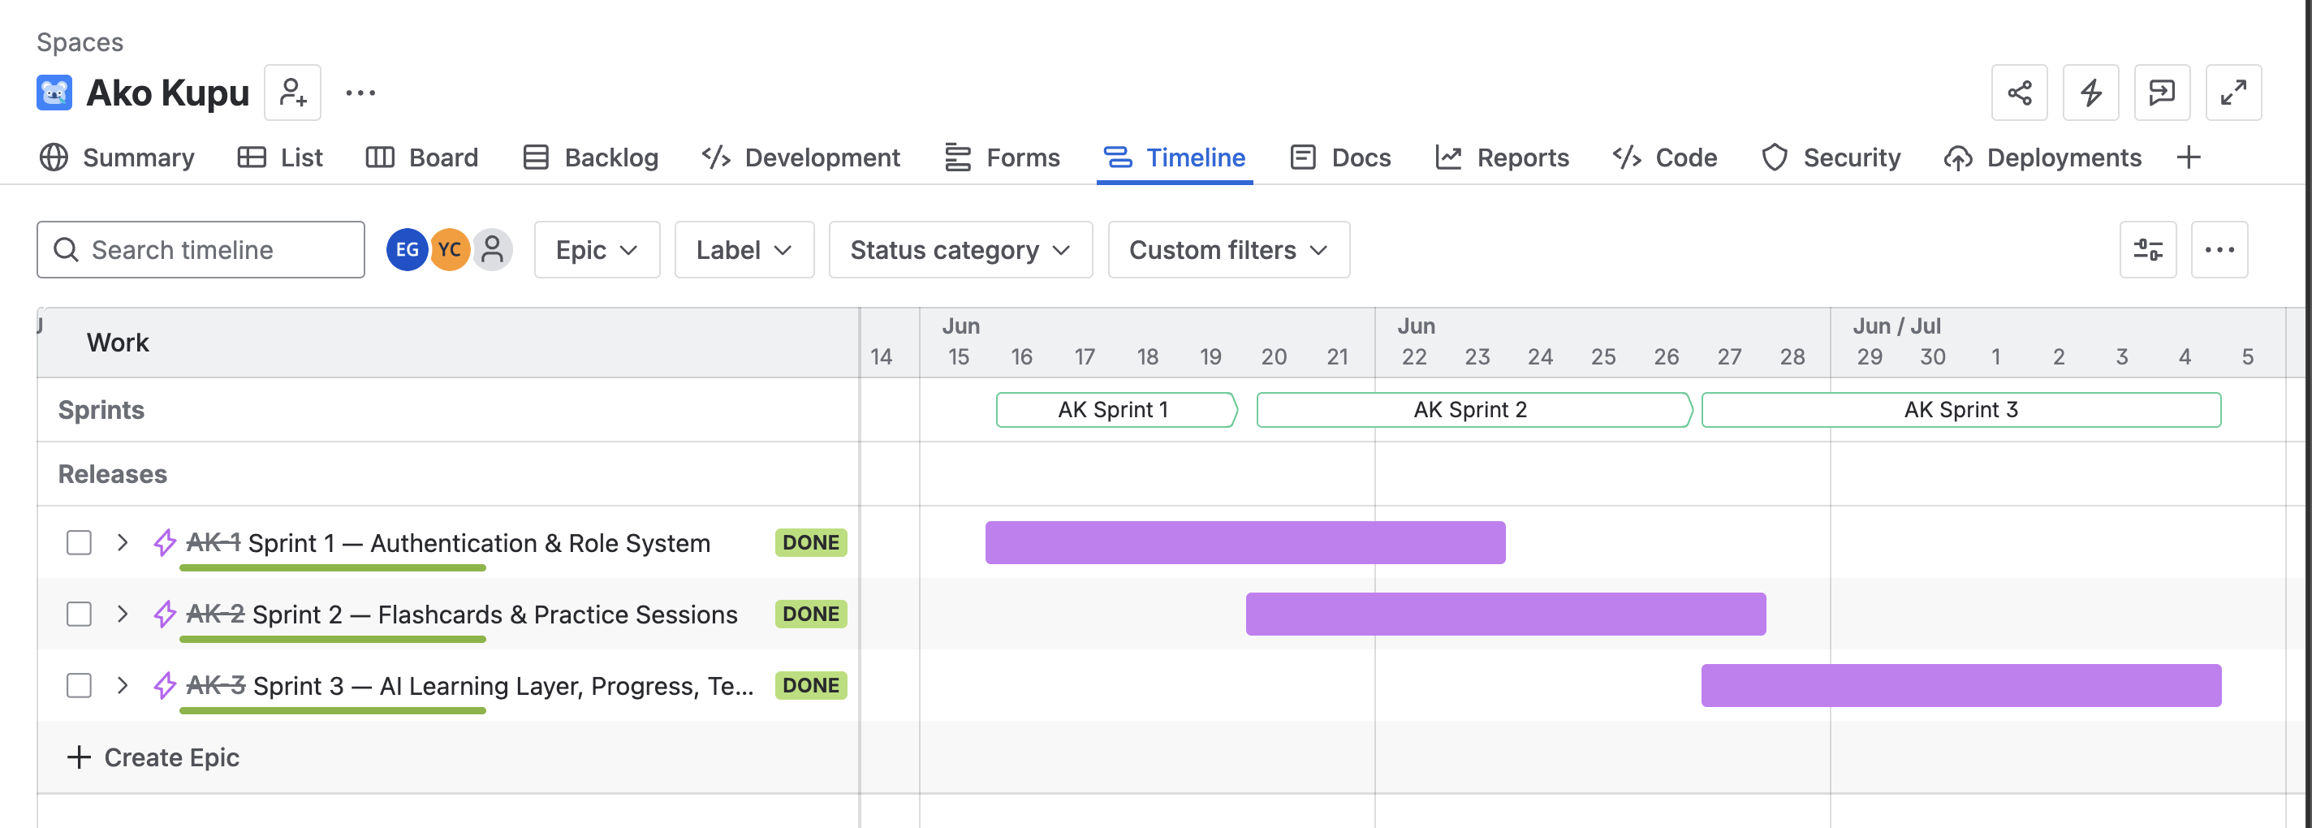

Day 0
Day 0 covered the foundation work between the kickoff (01 June) and 15 June. Its objective was to make the skeleton of the system real before any feature work started, and its deliverables were the Flask application-factory skeleton, the six-table database schema applied, the psycopg 3 connection verified through a /health/db endpoint, the Docker image building and deploying on Render, and the pylint configuration. The main infrastructure challenge of the project appeared at this stage: Render's free tier is IPv4-only while the original database host resolved to IPv6 only, so production could not connect to the database; the immediate solution was the provider's session pooler.

Sprint 1
Sprint 1 delivered the authentication and role system: registration, login, and logout with bcrypt password hashing; the User abstract base class with the Student, Kaiako, and Admin subclasses; the role_required decorator that enforces access control on every protected route; the three role dashboards; and the full CSS design system with the base templates. Its 12 tasks were closed in a three-day burst (16 to 18 June), and the sprint ended with 25 unit tests passing. No significant blocker appeared during this sprint, since the infrastructure problem had already been absorbed during Day 0.

Sprint 2
Sprint 2 built the core of the product. The Flashcard abstract base class and its three card types (vocabulary, phrase, whakataukī), the complete CRUD surface of the DatabaseManager class, kaiako flashcard and category management including archiving, the ākonga practice flow from category selection to the result page, progress tracking, admin user management, and the seed content all shipped in this sprint; its 14 tasks closed steadily between 16 and 27 June, and the automated suite reached 142 tests. The main challenge was test double drift: the method signatures of the in-memory FakeDB fell behind the real DatabaseManager, which the integration tests caught; the signatures have been kept locked in step since then.

Sprint 3
Sprint 3 added the AI learning layer and hardened the product for submission: the GeminiClient wrapper and the LearningAssistant service, personalised feedback on the result page, the Hoa Ako kōrero widget, graceful degradation when the API key is missing or the API fails, offline AI tests that mock the SDK, the acceptance run against production, the README and ER diagram, and the verified production deployment with the API key set. Eleven of its 12 tasks were resolved between 7 and 14 July, compressed towards the deadline; the twelfth, AK-15 (the cultural review of the seed vocabulary), was descoped when no reviewer could be secured. The challenge of this sprint was architectural rather than procedural: a third-party AI service must never break the learning flow; therefore, the AI was isolated behind a single entry point (build_assistant()), a missing key renders the pages without their AI sections, and an API failure produces a logged warning and a safe fallback string instead of a 500 error.

Sprint Deliverables

The following table summarises what each sprint delivered.
Table 5
Sprint Deliverables Summary
Sprint | Theme | Key deliverables
Day 0 | Foundation | Flask app-factory skeleton; 6-table schema applied; psycopg 3 connection verified via /health/db; Docker + Render pipeline live; pylint configuration
Sprint 1 | Authentication & role system | Registration, login, and logout with bcrypt; User ABC and three role subclasses; role_required RBAC; role dashboards; CSS design system and base templates; 25 unit tests
Sprint 2 | Flashcards & practice | Flashcard ABC and three card types; DatabaseManager CRUD surface; kaiako flashcard and category management including archive; ākonga practice flow and progress page; admin user management; seed content; integration tests (142 tests at close)
Sprint 3 | AI layer, testing & deploy | GeminiClient and LearningAssistant service layer; personalised result feedback; Hoa Ako kōrero chat; graceful degradation; offline AI tests; acceptance run; README and ER diagram; verified production deployment

Product Backlog

The backlog consists of 3 epics, one per sprint, and 38 tasks, of which 37 reached Done inside the project window; the one exception, AK-15 (the cultural review), was descoped when no reviewer could be secured. The epics are AK-1 (Sprint 1 — Authentication & Role System), AK-2 (Sprint 2 — Flashcards & Practice Sessions), and AK-3 (Sprint 3 — AI Learning Layer, Progress, Testing & Deployment). There was no separate story level, because at this scale a task linked to its specification row fulfils the same function; the epics group the tasks and carry the sprint boundaries. The complete export, with key, sprint, area, assignee, and status for every task, is reproduced in Appendix A; on the live board, each issue's Development panel links the branch, commits, and pull request that implemented it.

Development Metrics

The delivery metrics were computed from the created and resolved timestamps of every issue in the project window (16 June to 14 July). Sprint 1's 12 tasks closed in a three-day burst (16 to 18 June); Sprint 2's 14 tasks closed steadily over roughly two weeks (16 to 27 June); Sprint 3's 11 delivered tasks were compressed towards the deadline (7 to 14 July). Weekly throughput shows two full-speed delivery weeks of 13 tasks each, the deliberate pause between sprints (29 June to 5 July), and an 11-task final push; Figure 4 illustrates how the tasks flowed through the board. By assignee, Eric closed 25 tasks (8, 10, and 7 per sprint) and Yirong 12 (4 per sprint, fewer but larger template tasks); by area label, 26 tasks were backend, 6 frontend, and 6 shared. It is also necessary to clarify one measurement point: since the whole backlog was created in one batch on 16 June, Jira's created-to-resolved lead time measures backlog age rather than effort; therefore, the resolution windows and the weekly throughput are the meaningful delivery metrics for this project.

Figure 4
Tasks Flow Diagram
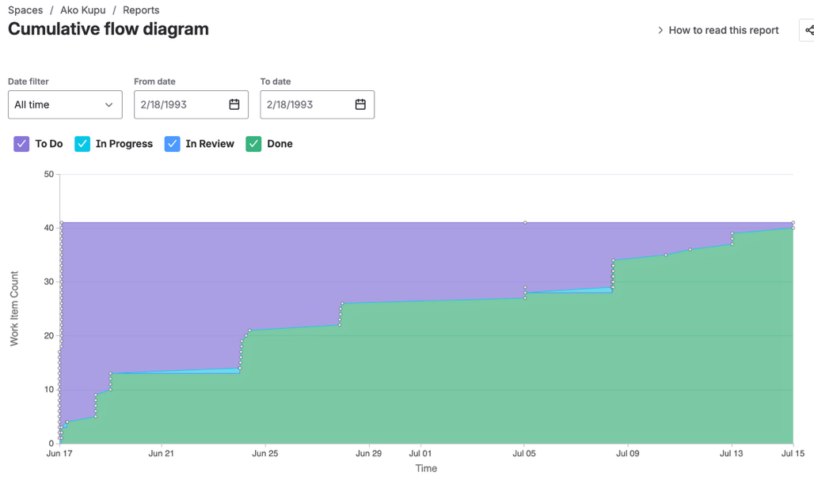

Collaboration & Version Control

Version control followed one rule: one issue, one branch, one pull request into main. Code review happened in the pull request (Figure 5); since each member owned one layer, the reviewer was by construction the consumer of the change, and any change to the seam between the layers had to update the interface contract in the same pull request. The GitHub-for-Jira integration made this discipline visible, since every branch, commit, and pull request is linked automatically to its Jira issue. After the assessment deadline, housekeeping continued under HK-n branches (pagination, expanded seed content to 7 categories and 120 cards, error-handler registration, and documentation synchronisation after the database migration); this continued activity indicates that the workflow remained usable beyond the submission itself.

Figure 5
GitHub branches and pull requests linked to Jira issues
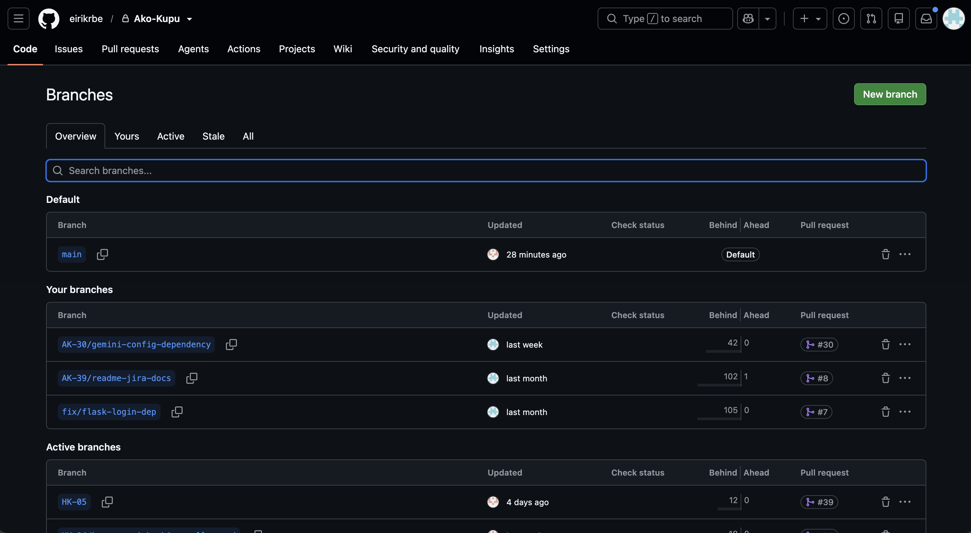

Software Design & Architecture

System Architecture

The system is a Flask application built with the application-factory pattern and organised into six blueprints, each owning one area of the route surface. Every page is server-rendered with Jinja2; the browser receives complete HTML, and JavaScript is limited to small interactions such as the card flip. A request enters through a blueprint route, passes the authentication and role guards, reaches the DatabaseManager class for data access, and returns a rendered template (Figure 6); the frontend sitemap (Figure 7) shows the pages that each role can reach. The AI functionality is deliberately not part of this request path: it is isolated in a single service module, which the routes call only when the feature is enabled.

Figure 6
Backend request flow
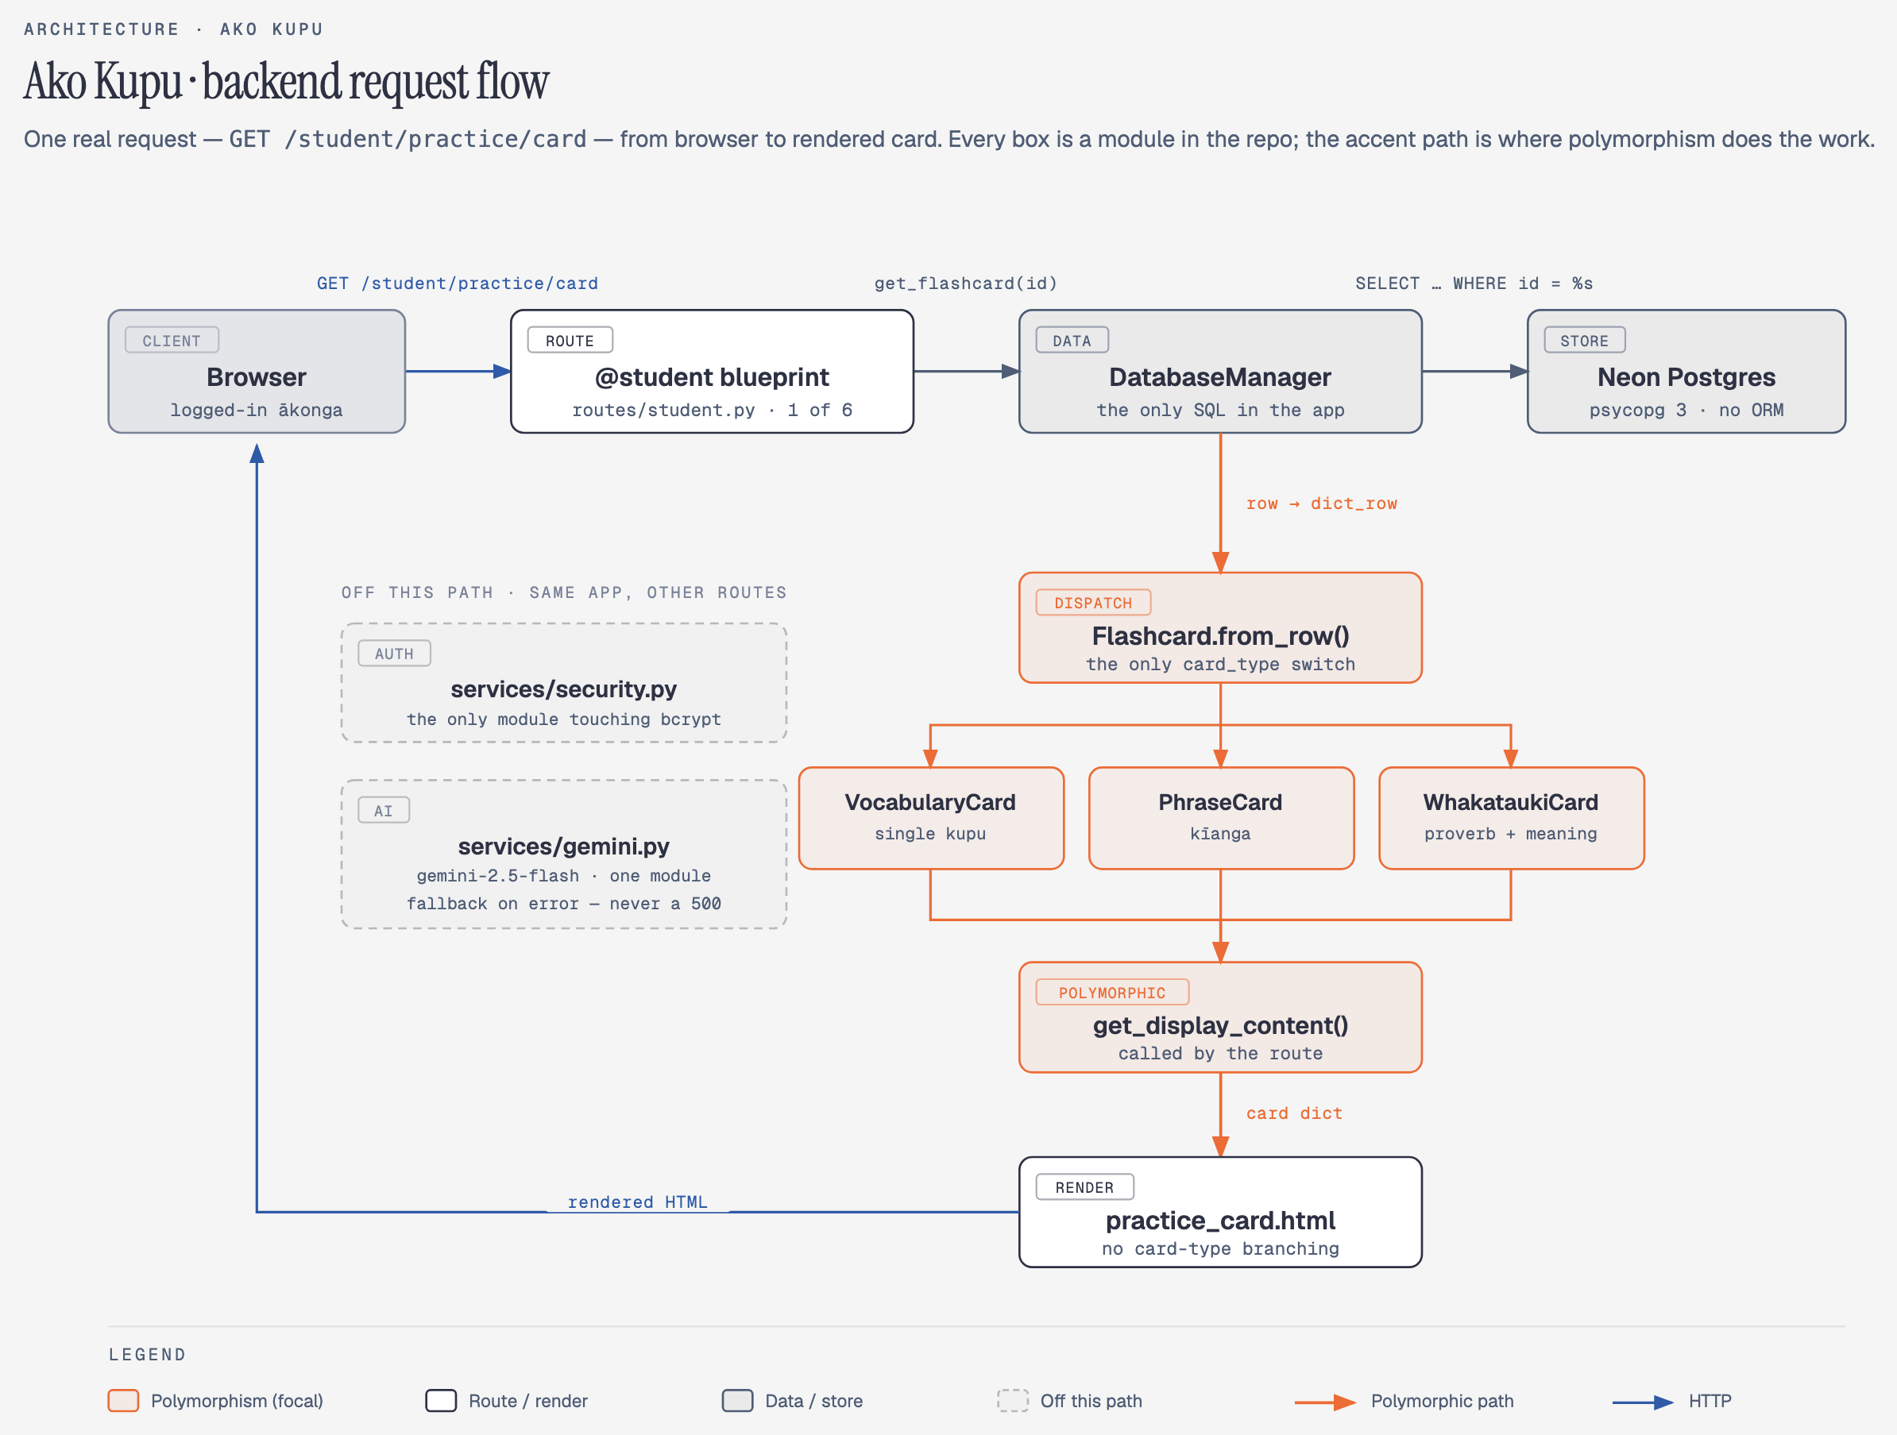

Figure 7
Frontend sitemap
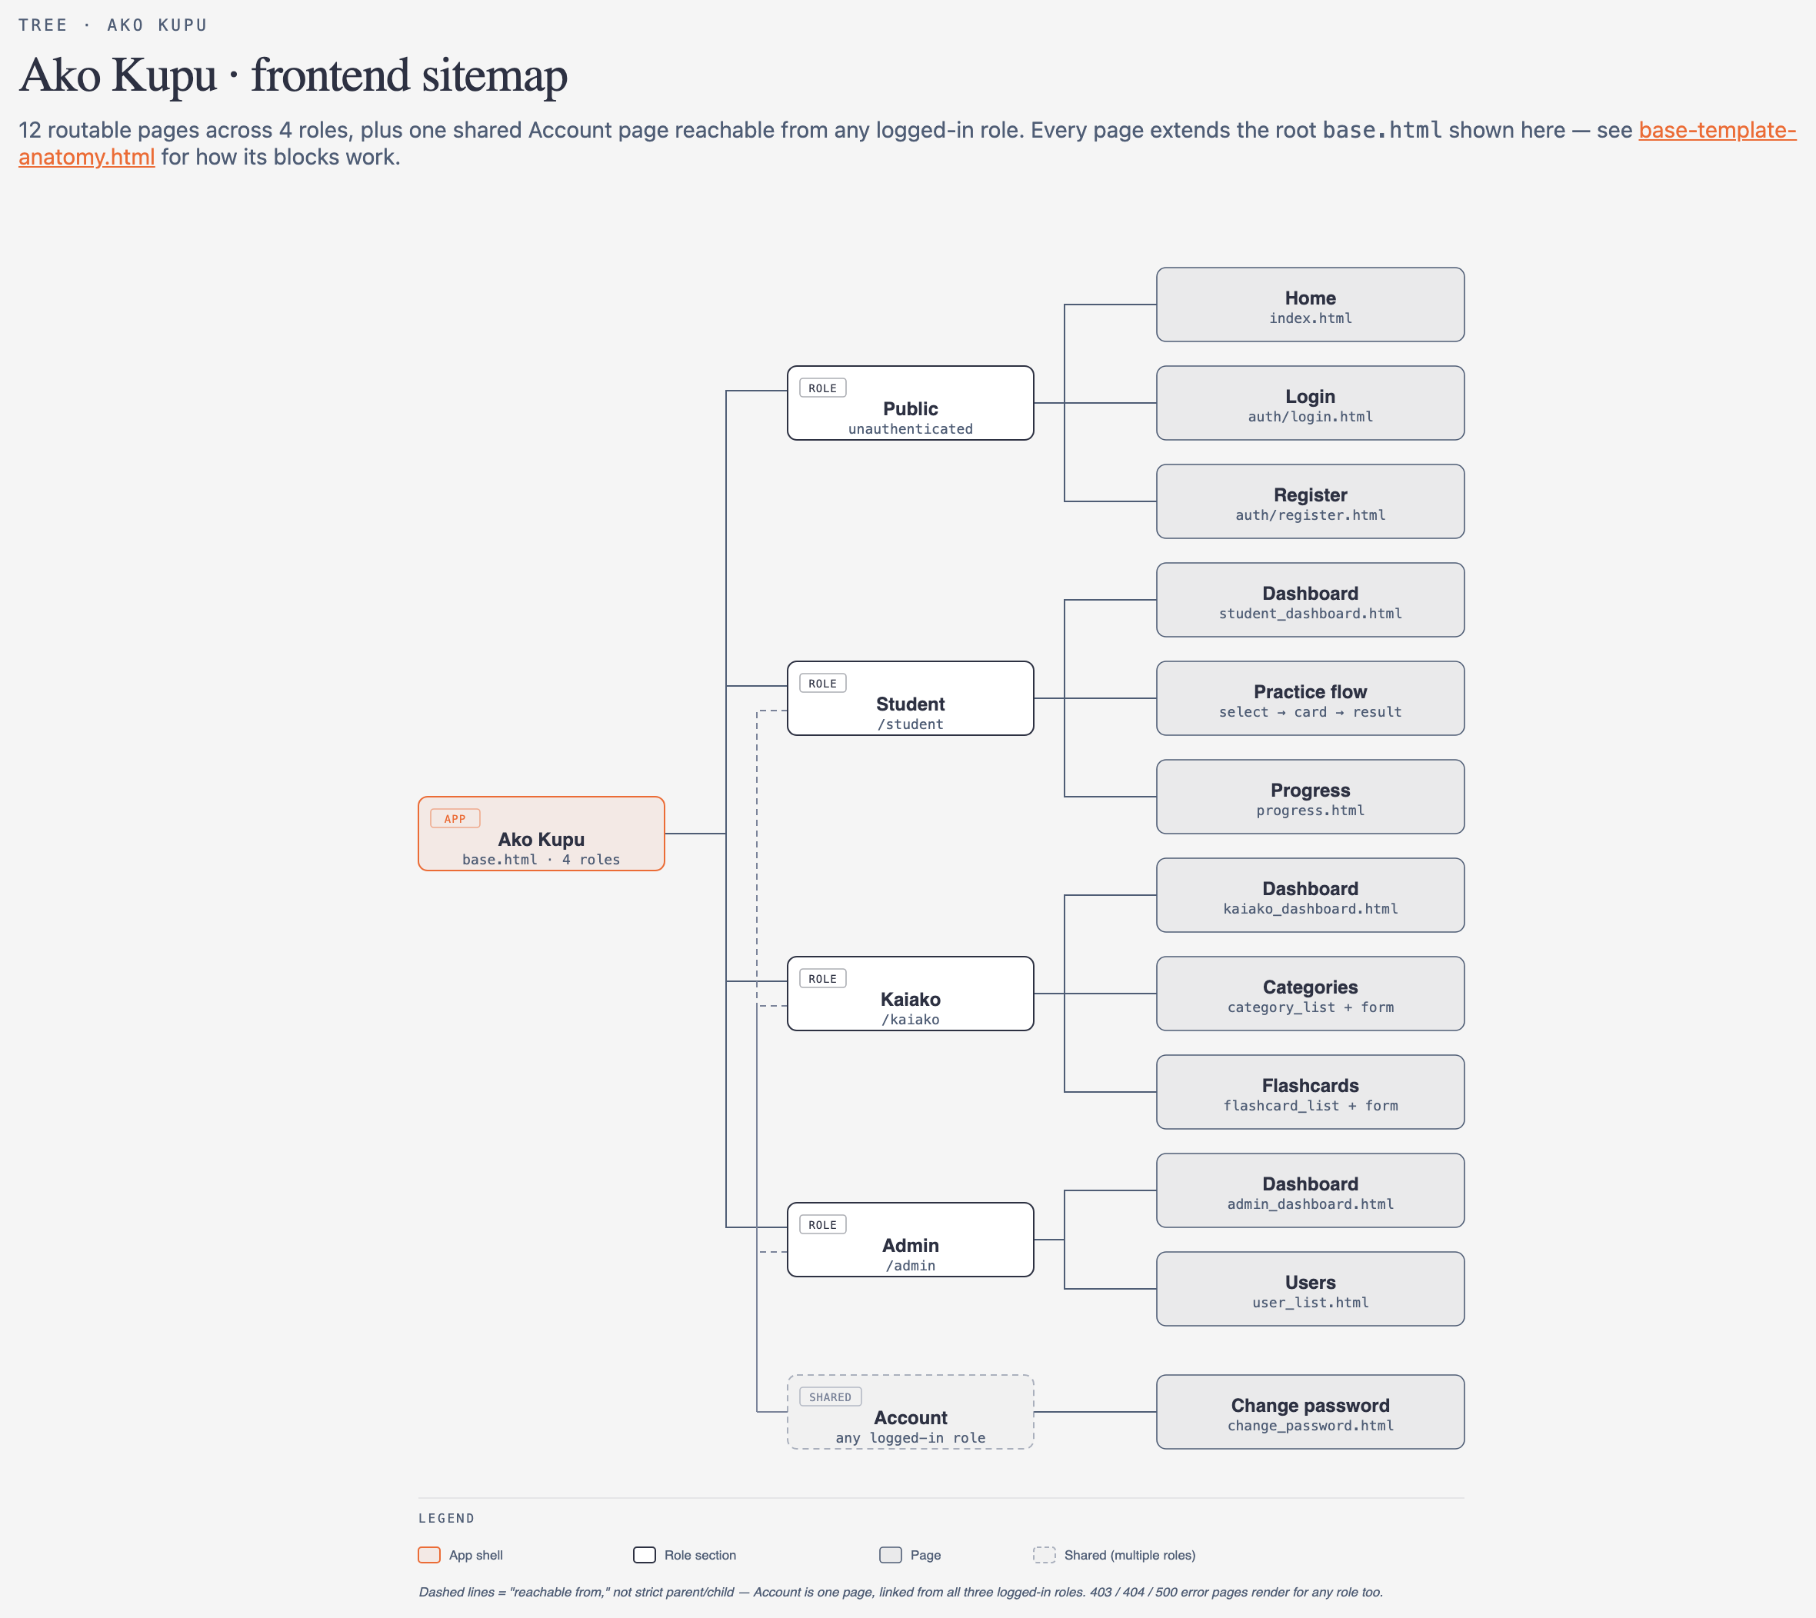

Database Design

The data model consists of six tables: users, categories, flashcards, practice_sessions, practice_attempts, and progress_records (Figure 8). Flashcards belong to categories and carry a type field for the three card types; a practice session groups the attempts of one five-card round; and progress_records accumulates per-user, per-category totals through an upsert, so the progress page reads one row per category instead of recomputing the whole history. Two design decisions are visible in the schema itself. First, pronunciation and audio_url are ordinary columns, which makes correct te reo presentation a property of the data model rather than a habit of whoever enters the content. Second, all SQL lives in the DatabaseManager class, a decision that later made the migration between database providers trivial, because no query had to change.

Figure 8
ER Diagram

Object-Oriented Design

The object-oriented core consists of two abstract hierarchies. User (an abc.ABC base) has the Student, Kaiako, and Admin subclasses, and Flashcard (also abstract) has one subclass per card type, including WhakataukiCard; neither base class can be instantiated directly, and unit tests enforce this. Polymorphism removes branching from the callers: the routes ask a card or a user for its behaviour instead of switching on a type or role field, so there are no if-chains over roles in the application code. Encapsulation concentrates persistence in DatabaseManager, whose public methods are the only path to SQL. The design follows the SOLID principles in a pragmatic way; the single-responsibility principle is the clearest example, with GeminiClient owning the API call, LearningAssistant owning the prompts, and DatabaseManager owning the SQL.

AI Architecture

The AI layer consists of two classes with distinct responsibilities: GeminiClient is a thin wrapper that owns the call to the Gemini API (gemini-2.5-flash), and LearningAssistant builds the prompts for the two features, the personalised session feedback and the Hoa Ako chat reply. The routes obtain an assistant through a single entry point, build_assistant(); when GEMINI_API_KEY is not configured, the pages render without their AI sections, and when the API fails at runtime, the user receives a safe fallback string while the failure is logged as a warning. Consequently, the AI is opt-in at runtime and can never turn a practice session into a 500 error; the offline test suite enforces this behaviour by mocking the SDK and forcing the key to be unset.

Deployment Architecture

The application runs as a Docker container on Render, which builds and deploys the image automatically on every push to main; the database is a hosted PostgreSQL instance on Neon; and all secrets (the database URL and the Gemini API key) enter the container as environment variables, so the image itself contains no credentials. The same Dockerfile serves development and production, which keeps both environments consistent, and a scheduled GitHub Action requests the health endpoint daily in order to confirm that the deployment is still alive.

Key Design Decisions

Some decisions deserve explicit justification. The Post/Redirect/Get pattern is applied on every POST, and the practice state lives in the signed Flask session; consequently, refreshing a page never double-counts an attempt. The AI is opt-in at runtime, as described above, because a third-party service must never block the core learning loop. Two mid-flight changes were recorded in the interface contract: the kōrero chat was originally sketched as a separate page but shipped as a floating widget on the practice screen, since a learning companion should be reachable while practising; and category management moved from the admin to the kaiako blueprint, since content belongs with the content owners. Finally, three deliberate upgrades from the original proposal were decided during Day 0 and Sprint 1: psycopg 3 instead of psycopg2, a custom CSS design system instead of Bootstrap, and Jira with Confluence instead of GitHub Projects.

Cost Estimation

Labour Costs

The actual cash spend of the project was NZ$0, since every service ran on a free tier; the figures in this section therefore estimate what the same project would have cost at market rates. Labour assumes two developers working 15 hours per week during the five project weeks (75 hours each) at a notional graduate rate of NZ$55 per hour.
Table 6
Labour Cost Breakdown
Role | Person | Hours | Rate | Cost (NZ$)
Backend developer: routes, models, DatabaseManager, AI service layer, tests | Eric Gomez | 75 | $55/h | 4,125
Frontend developer: templates, CSS design system, JavaScript, UI design, deployment | Yirong Chen | 75 | $55/h | 4,125
Total labour |  | 150 |  | 8,250

Tools & Services

Every tool ran on its free plan. The commercial column shows the entry-level paid plan that a commercial deployment of the same stack would require.
Table 7
Tools and Services Cost Comparison
Tool | Plan used | Our cost | Commercial equivalent
Render | Free | $0 | Starter, ≈ US$7/month
Neon PostgreSQL | Free | $0 | Launch, ≈ US$19/month
Google Gemini API | Free tier | $0 | Pay-as-you-go per token
GitHub | Free | $0 | Team, US$4/user/month
Jira + Confluence | Free (up to 10 users) | $0 | Standard, ≈ US$8/user/month
Docker | Free | $0 | Not required at this scale

Resources

The physical resources required no expenditure either. Both developers worked on their own laptops; the hosting and the database run on the free tiers described above; and no domain was purchased, since the application is served from the free onrender.com subdomain.

Project Cost Summary

In summary, the project cost NZ$0 in real terms and approximately NZ$8,350 at commercial rates: NZ$8,250 of labour plus roughly NZ$100 of tools and services for the five weeks. The gap between the two figures is itself a finding: the free tiers of Render, Neon, and the Gemini API are sufficient for a complete, deployed, AI-enabled product at this scale, although a commercial deployment would need the paid plans in order to remove free-tier constraints such as the IPv4-only networking that complicated the original database connection.

Acceptance Criteria & Testing

Testing Strategy

Testing operated on four levels. Unit tests cover the isolated pieces: password hashing, the model hierarchies, and the polymorphic display methods. Route tests exercise every blueprint. End-to-end integration tests walk the two flows that matter most, the kaiako flashcard CRUD flow and the complete practice session. Acceptance testing, finally, verified the finished product against the success criteria in production. The automated suite consists of 193 tests and is fully offline and deterministic: an in-memory FakeDB stands in for DatabaseManager, the Gemini SDK is mocked, and the test fixture forces GEMINI_API_KEY to be unset, so the suite touches neither the real database nor the live API. A lint gate accompanies the tests: pylint at or above 8.0 is enforced by configuration, and the project closed at 9.85/10.

Acceptance Criteria

Acceptance criteria were written into the user stories from the beginning: every story carries observable criteria, and each criterion is linked to the functional requirement that implements it. For the final acceptance run these were consolidated into 9 success criteria plus 3 AI criteria, each phrased so that it can be verified with a scripted HTTP flow and a SQL check rather than by opinion. For example, the first criterion does not simply require that registration works; it requires that the stored password is a bcrypt hash and that no plaintext exists in the database.

Test Results

The acceptance run was executed on 14 July 2026 against the production deployment, with scripted HTTP flows and SQL verification of every claim; all test data was removed afterwards, and the row counts were confirmed back to baseline. All 12 criteria passed. Figure 9 shows the automated suite and the lint score at close, and the table below reproduces the acceptance results; the detailed records are in Appendix D.

Figure 9
Pytest and Pylint final results
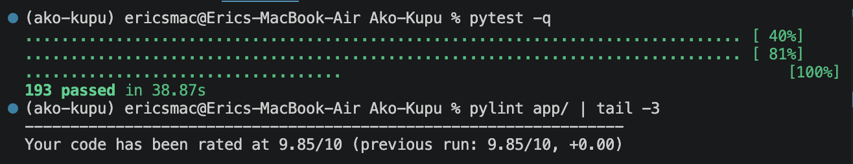

Table 8
Acceptance Test Results
# | Criterion | Result
1 | Ākonga registers and logs in securely (bcrypt hash in the database, no plaintext) | Pass
2 | Practice session of at least 5 cards with score (3/5 gives 60%, missed kupu listed) | Pass
3 | Progress updates after at least 3 sessions (15 attempts, 12 correct, 80%) | Pass
4 | Kaiako flashcard CRUD by category (create, edit, delete, filter) | Pass
5 | At least 3 flashcard types (vocabulary, phrase, whakataukī) | Pass
6 | Progress display matches the database rows exactly | Pass
7 | Admin manages users; kaiako manages categories (role change, archive and unarchive) | Pass
8 | Neon PostgreSQL stores and retrieves all entities (six-table SQL spot-check) | Pass
9 | Render deployment works (HTTP 200 on all flows, branded 403 on wrong role) | Pass
AI-1 | Personalised feedback renders and names the missed kupu | Pass
AI-2 | Kōrero chat replies coherently ("Kia ora kōrua" when greeting two people) | Pass
AI-3 | Graceful degradation with the key unset (no AI section, no 500 errors) | Pass

Production Validation

Production validation went beyond HTTP status codes. The nine success criteria were verified directly against the live Render deployment, including the branded 403 page for wrong-role access; the six tables were spot-checked in Neon with SQL in order to confirm that every entity is stored and retrieved correctly; and the AI features were verified twice, first live with the API key set and then locally with the key unset, which confirmed the graceful degradation path. Since Render builds the image automatically from main, the deployment that passed these checks is the same container that the repository produces.

Cultural Acceptance

Cultural acceptance was approached through permission compliance and source fidelity. The pronunciation audio in the seed content is reused within the scope of the permission granted by Manatū Taonga Ministry for Culture & Heritage (Figure 2; the correspondence is reproduced in Appendix E); the seed vocabulary preserves the macrons and the topic grouping of its source material; and the interface keeps macrons in all user-facing copy, while code identifiers use respectful ASCII equivalents (WhakataukiCard, /korero). A consultation process with kaiako is planned as future development, so that acceptance by the communities the product serves can be evidenced directly; the kaiako review of the seed vocabulary that was scheduled inside the project window (AK-15) was descoped when no reviewer could be secured.

Challenges & Lessons Learned

The significant challenges of the project all appeared at seams: between the application and its infrastructure, between the application and a third-party AI service, between the test suite and the real database, and between two developers working on one codebase. None of them blocked delivery; however, each one forced a decision that left a transferable lesson. The following table records them in the problem, solution, and lesson format.

Table 9
Challenges, Solutions, and Lessons Learned
Challenge | Solution | Lesson learned
Render's free tier is IPv4-only, while the original database host resolved to IPv6 only, so production could not connect to the database | The provider's session pooler as the immediate fix; a full migration to Neon PostgreSQL, with zero schema changes, as the definitive one | The no-ORM, plain-SQL decision made the database swap trivial; an infrastructure constraint can end up improving the architecture
A third-party AI API must never break the learning flow | The AI is isolated in one service module behind build_assistant(); a missing key renders the pages without their AI sections, and an API failure produces a logged warning and a safe fallback string | Treat external dependencies as optional at runtime
Test double drift: the method signatures of the in-memory FakeDB fell behind the real DatabaseManager | The integration tests caught the drift; the signatures have been kept locked in step since then | Integration tests guard the seams that unit tests cannot see
Two developers, one codebase, five weeks | The frozen interface contract, one branch per issue, and pull requests into main | For a small team, an interface contract replaces coordination meetings

Te Tiriti o Waitangi & Cultural Considerations

Partnership
Partnership, in this project, meant engaging with the people and institutions who hold the material rather than working around them. The clearest expression is the exchange described in Section 2.5: before any pronunciation audio entered the seed content, the team requested permission from Manatū Taonga Ministry for Culture & Heritage and waited for the approval before proceeding. The same posture operated inside the team: since the product teaches a language that neither developer speaks natively, decisions about the language were treated as decisions to be verified against the source material, not owned.

Participation
Participation is built into the product's organising idea, ako, the reciprocal learning between kaiako and ākonga. The kaiako role manages flashcards and categories through the same web interface that students use, with no technical knowledge required, so teachers participate in shaping the content rather than requesting changes from a developer; ākonga register themselves and direct their own practice by choosing what to study. In this sense the software does not merely serve two audiences: it gives both of them an active part in the learning loop.

Protection
Protection of te reo as taonga is implemented in the schema and the conventions, not only stated. Macrons, pronunciation guides, and audio are first-class database columns; the user interface preserves macrons in every piece of copy, while code identifiers use respectful ASCII equivalents (WhakataukiCard, /korero); the seed vocabulary keeps the topic structure of its source instead of an arbitrary reorganisation; and no reused material entered the product without formal permission. These are small mechanisms; however, they make correct and respectful presentation the default rather than an act of individual care.

Figure 10
Practice card — macrons, pronunciation guide, and audio (Whakarongo)
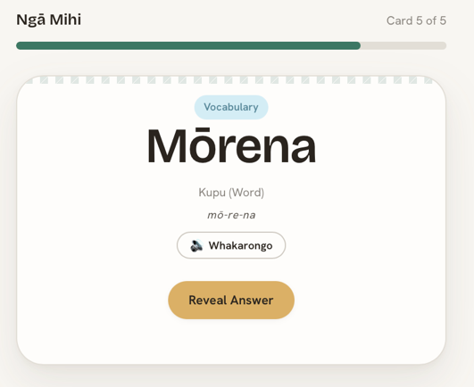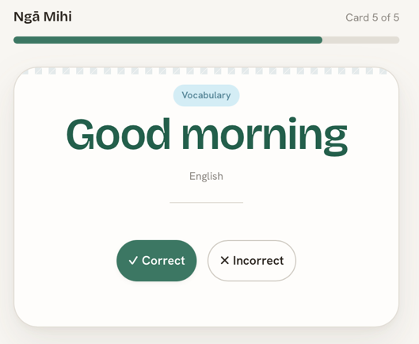

External Cultural Engagement
The team's external cultural engagement was the formal exchange with Manatū Taonga Ministry for Culture & Heritage. The request asked for permission to reuse the pronunciation audio of the "100 Māori words" resource; the approval was given by Jamie Mackay, Pou Taki ā Matihiko Matua | Senior Adviser Digital, and the full correspondence is reproduced in Appendix E (see also Figure 2). The conditions of that permission were treated as requirements: the audio is used within the agreed scope, and the source is acknowledged. A consultation process with a kaiako remains planned as future development, so that the product's cultural acceptance can rest on review by the community it serves and not only on fidelity to the source.

Ethical Use of Data & Tools

Dataset
The only external dataset in Ako Kupu is the "100 Māori words every New Zealander should know" resource, published on the NZ History website by Manatū Taonga Ministry for Culture & Heritage and obtained directly from that public page (see References). It supplies the seed vocabulary and the pronunciation audio. The site's copyright terms (Ministry for Culture and Heritage, 2025) license MCH-owned text and audio under the Creative Commons Attribution-NonCommercial 3.0 New Zealand licence (https://creativecommons.org/licenses/by-nc/3.0/nz/), which permits copying, distribution, and adaptation for non-commercial purposes with attribution; these terms cover use for learning, study, and research, and Ako Kupu, a non-commercial educational project, satisfies them. The team did not rely on the licence alone: written permission to reuse the audio was requested from and granted by Manatū Taonga on 24 June 2026 (Appendix E), and the credit specified in that permission, "NZ History by Manatū Taonga", is displayed in the footer of every page of the application, linked to the source.

Tools
The application is built entirely on open-source software used under its published licences: Flask, Jinja2, and Flask-Login (BSD/MIT), psycopg 3 (LGPL-3.0), bcrypt and the google-genai SDK (Apache-2.0), gunicorn and pytest (MIT), pylint (GPL-2.0), and PostgreSQL (PostgreSQL License). The hosted services (Render, Neon, the Google Gemini API, GitHub, Docker, and Atlassian Jira and Confluence) are used within the terms of their free plans for non-commercial educational projects.

Personal and sensitive data
The system stores no real learner data: all production accounts are the team's own test accounts, and the acceptance-run data was removed afterwards with the row counts verified back to baseline. Prompts sent to the Gemini API contain only the session score, the missed kupu, and the chat text; they never contain names, email addresses, or credentials. All secrets enter the deployment as environment variables and appear in neither the repository nor this report, and the database host is de-identified in Appendix C.

Access to project materials.
This submission is self-contained: the backlog, sprint documentation, requirements, and acceptance records are included as exported appendices rather than links. The GitHub repository, the Jira board, and the Confluence space referenced on the cover page are private workspaces accessible only to the team and the assessor. The live application is publicly reachable because deployment on free public hosting was one of the supervisor's three approval conditions.

Conclusion
Ako Kupu set out to give ākonga a structured, culturally grounded way to practise Te Reo Māori vocabulary and to give kaiako full control of the learning content without technical knowledge, and it delivered both: the application is live on Render, backed by Neon PostgreSQL, with the five-card practice loop, per-category progress tracking, role-separated management, and an AI learning layer that degrades gracefully when the service is unavailable. The evidence of quality is concrete rather than claimed: 193 offline automated tests, a pylint score of 9.85/10, and a documented acceptance run in which all 9 success criteria and all 3 AI criteria passed against the production deployment. The three supervisor conditions (free hosting, Docker, and an integrated AI/LLM API) were met.
The way of working proved as important as the product. Two developers shipped 37 of the 38 backlog tasks across Day 0 and three sprints by splitting the system by layer, freezing the interface contract between the layers, and letting the toolchain carry the coordination; the process survived contact with real problems, from the IPv4 constraint to test double drift, and each of them left a recorded lesson. Future development has a clear direction: a consultation process with kaiako, so that cultural acceptance can rest on community review; the continued content growth that the post-deadline housekeeping already started (seven categories and 120 cards); and the paid service tiers that a commercial deployment would require. The project therefore closes not only with a working product but also with a process the team would reuse.

(Copyright, Disclaimer and Moderation Information | NZ History, n.d.; Docker, Inc, n.d.; Docs + Quickstarts | Render, n.d.; Gemini API, n.d.; Jira Cloud Support | Jira Cloud, n.d.; Neon Documentation - Neon Docs, n.d.; PostgreSQL: Documentation, n.d.; Psycopg 3.3.5.Dev1 Documentation, n.d.; Welcome to Flask — Flask Documentation (3.1.x), n.d.)

References

Copyright, Disclaimer and Moderation information | NZ History. (n.d.). Retrieved 19 July 2026, from https://nzhistory.govt.nz/copyright
Docker, Inc. (n.d.). Docker Documentation. Retrieved 19 July 2026, from https://docs.docker.com/
Docs + Quickstarts | Render. (n.d.). Retrieved 19 July 2026, from https://render.com/docs
Gemini API. (n.d.). Google AI for Developers. Retrieved 19 July 2026, from https://ai.google.dev/gemini-api/docs
Jira Cloud support | Jira Cloud. (n.d.). Atlassian Support. Retrieved 19 July 2026, from https://support.atlassian.com/jira-software-cloud/
Neon documentation—Neon Docs. (n.d.). Neon. Retrieved 19 July 2026, from https://neon.com/docs/introduction
PostgreSQL: Documentation. (n.d.). Retrieved 19 July 2026, from https://www.postgresql.org/docs/
Psycopg 3.3.5.dev1 documentation. (n.d.). Retrieved 19 July 2026, from https://www.psycopg.org/psycopg3/docs/
Welcome to Flask—Flask Documentation (3.1.x). (n.d.). Retrieved 19 July 2026, from https://flask.palletsprojects.com/en/stable/

Appendices

Appendix A — Complete Product Backlog - Jira.html
Appendix B — Sprint Planning & Backlog – Confluence.pdf
Appendix C — Requirements & Project Plan.pdf
Appendix D — Acceptance Testing Records - Confluence.pdf
Appendix E — Source-material permission - RE_ Permission request — reuse of _100 Māori words.eml

Figures
Figure 1 GitHub Tree Sprints 1 and 2 6
Figure 2 Permission request — reuse of "100 Māori words" pronunciation audio 7
Figure 3 Jira Timeline Sprints Overview 13
Figure 4 Tasks Flow Diagram 16
Figure 5 GitHub branches and pull requests linked to Jira issues 17
Figure 6 Backend request flow 18
Figure 7 Frontend sitemap 19
Figure 8 ER Diagram 20
Figure 9 Pytest and Pylint final results 24
Figure 10 Practice card — macrons, pronunciation guide, and audio (Whakarongo) 28

Tables
Table 1 Team Structure 5
Table 2 User Roles and Permissions 9
Table 3 Representative User Stories and Acceptance Criteria 10
Table 4 Development Tools and Responsibilities 12
Table 5 Sprint Deliverables Summary 15
Table 6 Labour Cost Breakdown 22
Table 7 Tools and Services Cost Comparison 22
Table 8 Acceptance Test Results 24
Table 9 Challenges, Solutions, and Lessons Learned 26

